Occultation of Mars : December 2022
F. Starr (London GB)
An occultation occurs when the Moon passes in front of a planet. Quite a rare event, although the Moon appears to be such a large object. The Moon, in fact, is only about half a degree in angular size. Or, in real numbers, about the same as looking at a Euro or Pound coin from 2.5 metres away.
That is one problem, whereby the chances of the Moon covering a planet are pretty remote. The other issue is that despite having eight planets (Pluto now counts as a very distant asteroid), only four count as good occulting objects. In order, they are Jupiter, Mars, Saturn and Venus. Venus, has its own problems. Although very bright, it will be occulated in the evening or morning sky, when the sky is light and when Moon looks relatively dim. And just a crescent moon. Not full, as it was on this occasion.
The latest occultation could be seen from Britain, Ireland and much of Europe, and was ideal. Except it took place in the early hours of the December 9th! The Moon was very high in the sky, when amazingly, for London, the sky was clear. So clear it was possible to see Mars and the Moon, over to the east during the evening. At that time the separation was about the width of a hand span at the end of one’s arm. I was watching from Norbury, which is about 12km due south from the centre of London.
Over the next few hours, as Mars and the Moon moved westerly, round the sky, along with the rest of the stars. But as they moved further west, the Moon got closer to Mars. That is, the Moon drifts eastwards, relative to Mars and the other stars, by a distance equal to its own diameter every hour. By 3.30am, the Moon was about one-and-a-half diameters from Mars and creeping ever closer.
By this time the glare from the Moon was tending to obscure Mars (my eyesight is not so good), but I could see the two perfectly well through a pair of cheap binoculars.
My son was observing from Sutton, which is a bit further out from the centre of London and towards the south west. He took some photographs that were timed. The resolution was slightly worse than what I saw through the binoculars. Here are the pictures and the timings.
Mars is just a tiny point that is northwest of the Moon. On the first picture the separation is about 6 mm. Four minutes later the separation is about 2 mm. The final picture has been enlarged. A few seconds after this shot Mars was obscured.
The next occultation that can be seen from London, in 2024, will not be very good, occurring in the late morning winters’ twilight at just after 9.00 am on the 18th December. After that, the very young people in the capital will have a long wait. Until the early hours of the 16th August 2052!
Dr Fred Starr with help from M.Starr
2nd Feb 2023

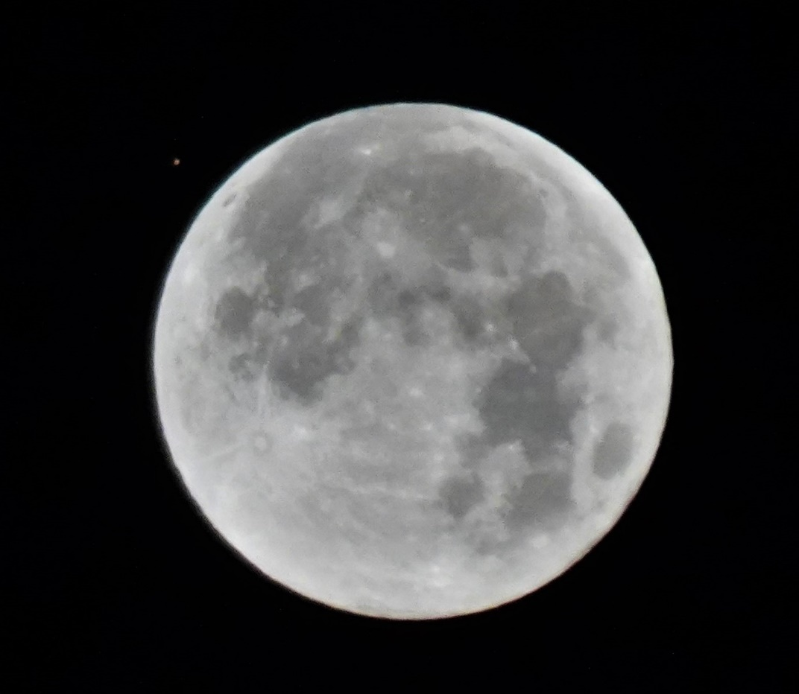

DSC00140 – taken 04:53:08

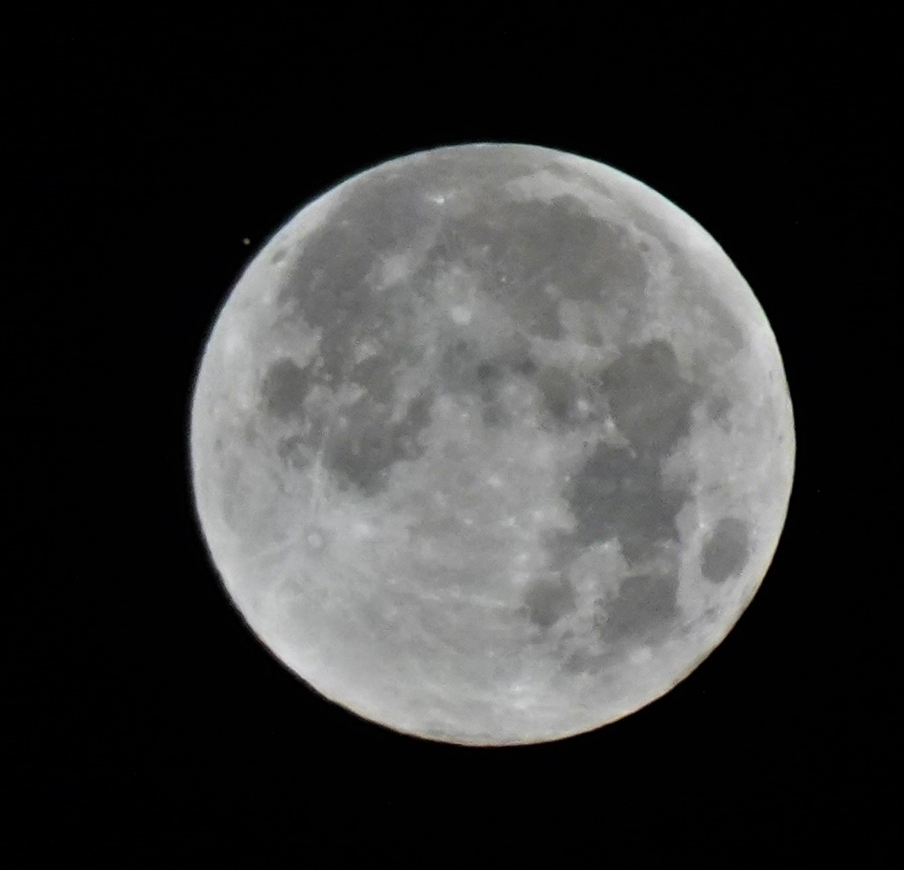

DSC00144 - taken 04:57:24

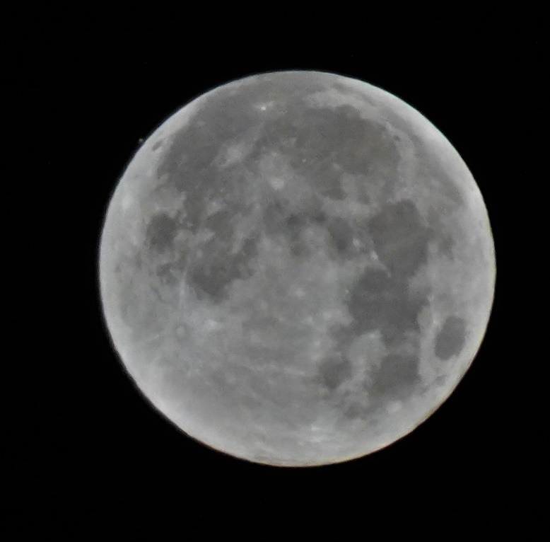
DSC00145 - taken 04:58:30

